***Tube Frame [1.0]***

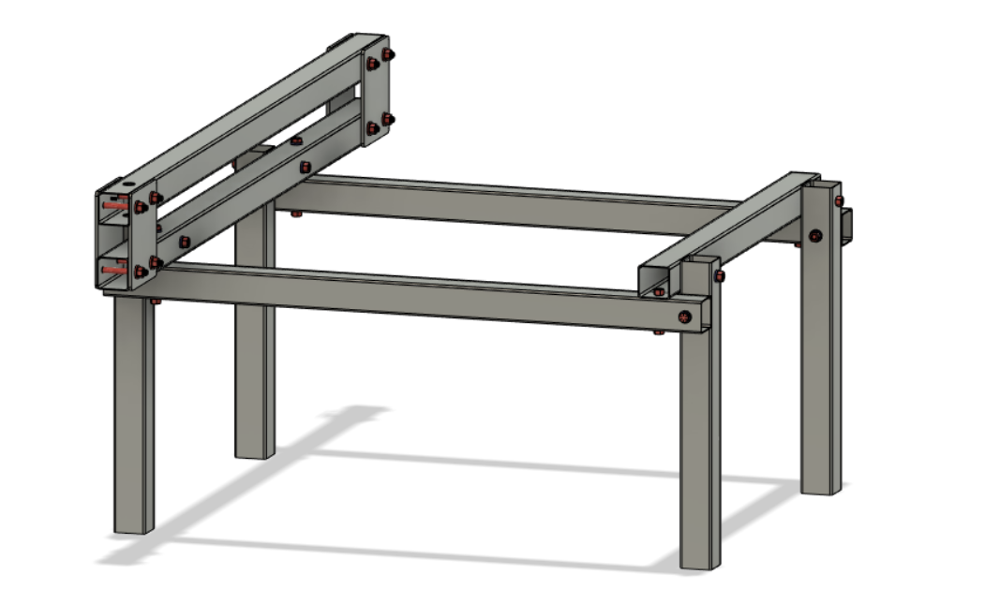

***Y-Axis [1.1]***

**Parts Needed**

**1x 51” Y-Lower Frame Rail**

**1x 51” Y-Upper Frame Rail**

**2x Y-Connecting Plate #1**

**1x Y-Connecting Plate #2**

**1x Y-Connecting Plate #3**

**8x 3/8”-3” bolts**

**8x 3/8” washers**

**8x 3/8” nuts**

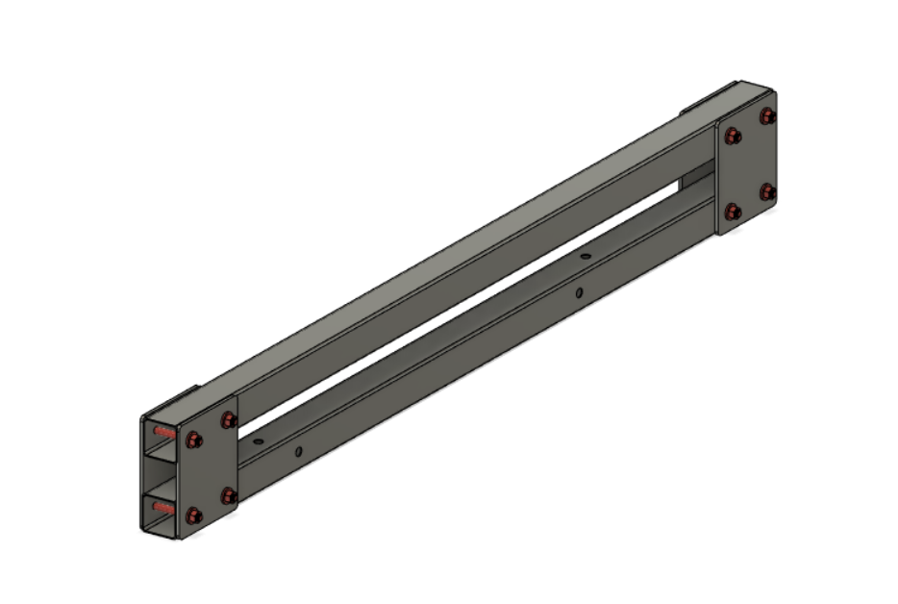

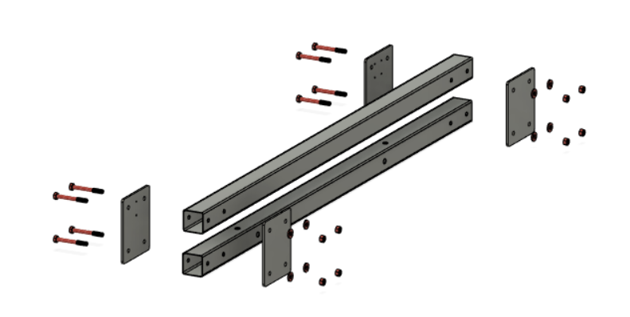

**IMPORTANT:** To make sure that the upper and lower frame rails are parallel to each other read the following

**Pro Tip:** Use one of the legs as a spacer between the upper and lower frame rails, place the upper frame rail on top of the leg and clamp the whole assembly in place. Use the holes in the connecting plates as guides to drill the holes for the 51” Upper Y-Axis Frame Rail.

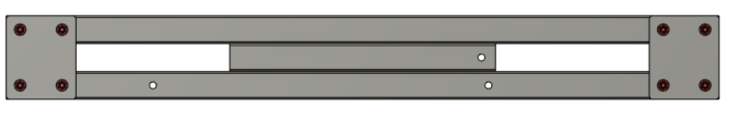

***Outside Corner [1.2]***

Repeat this step twice

**Parts Needed**

**1x 30” X-Frame Rail**

**2x 38” Y-Frame Rail**

**2x Legs**

**8x Bolt Spacers (3D Printed)**

**2x 3/8” - 5” Bolts**

**4x 3/8” - 2.5” Bolts**

**6x 3/8” Nuts**

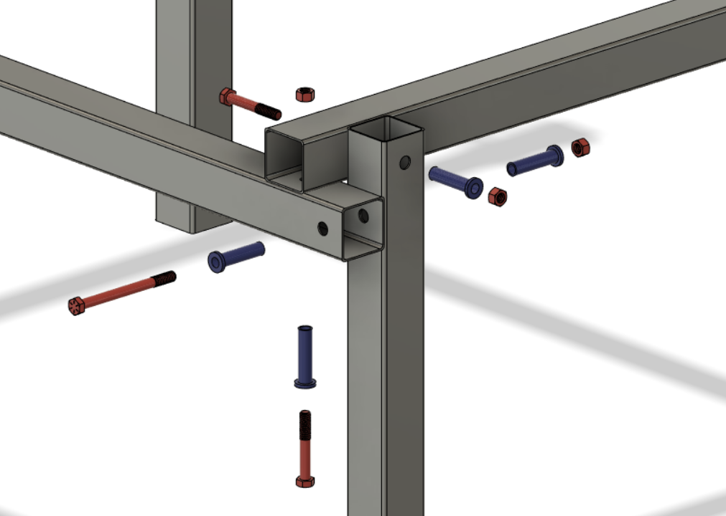

***Y-Axis Corner [1.3]***

Repeat this step twice

**Parts Needed**

**1x Y-Axis Assembly**

**1x Outside Corner Assembly**

**2x Legs**

**12x Bolt Spacers(3D Printed)**

**6x 3/8” - 5” Bolts**

**6x 3/8” Nuts**

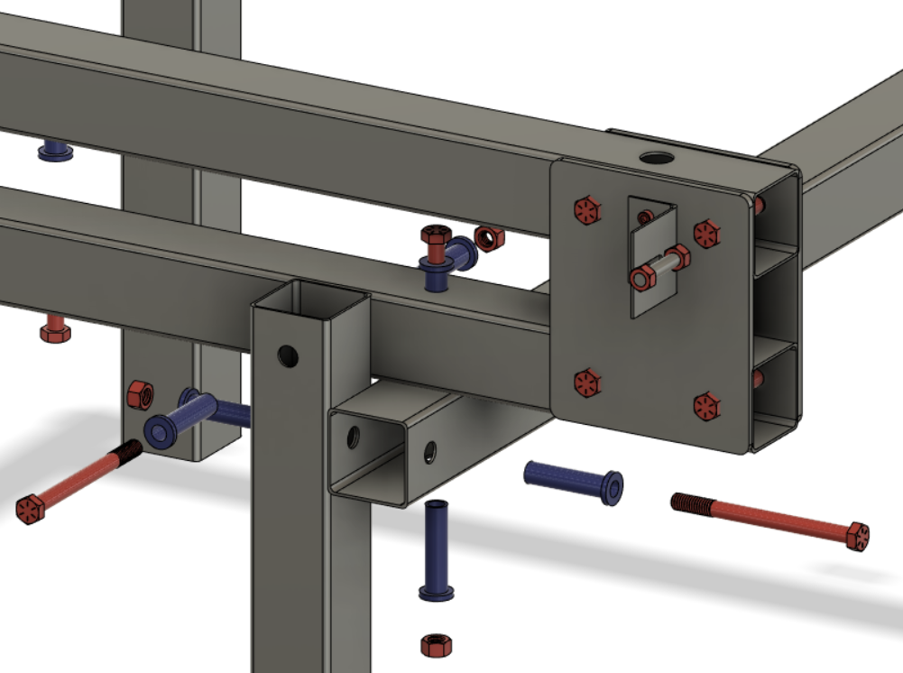

Watch for reference <https://www.youtube.com/watch?v=lhejn2-bwxc&list=PLWACT6mAqAyVz0Aqc3zoBX9DPsVudicCc&index=3>

***Belt Mounts [1.4]***

Weld the highlighted areas. Make 2 of each unless you are 3D printing the belt mounts.

**Parts Needed**

**1x Active Belt Mount**

**2x 5/16” Nuts, Drilled to 5/16”**

**1x 5/16” - 1.25” Pin**

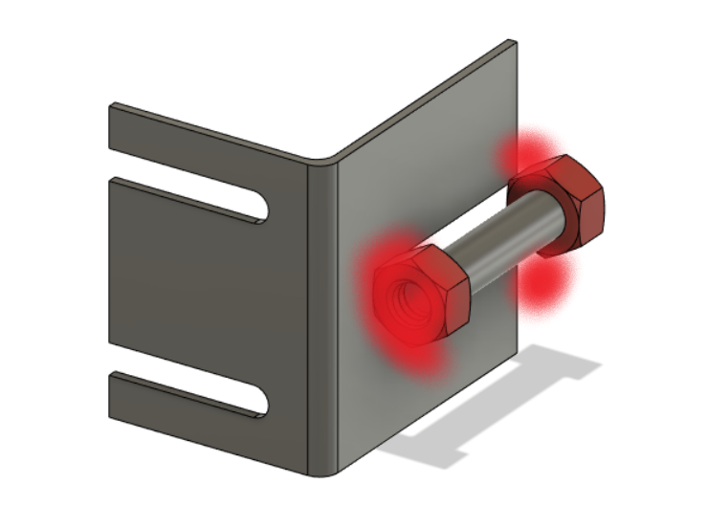

**Parts Needed**

**1x Idle Belt Mount**

**2x 5/16” Nuts, Drilled to 5/16”**

**1x 5/16” - 1.25” Pin**

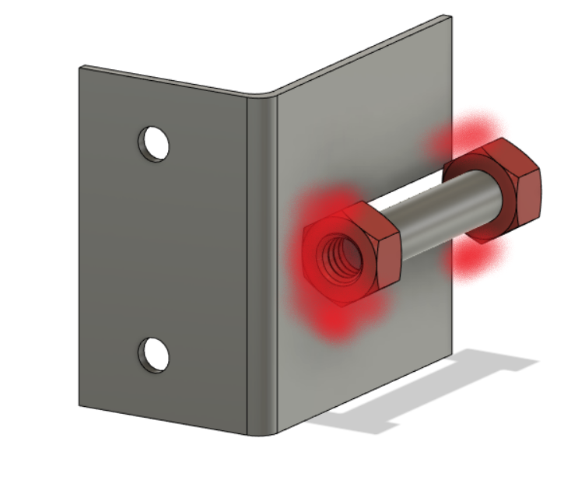

***Complete Tube Frame [1.5]***

**Parts Needed**

**1x Tube Frame Assembly**

**1x Active Belt Mount**

**1x Idle Belt Mount**

**1x Belt Tensioner (3D Printed)**

**1x 1/4”- 2.5” All Thread Bolt**

**2x #10 washers**

**6x #10-32 - 5/8” Cap Screws**

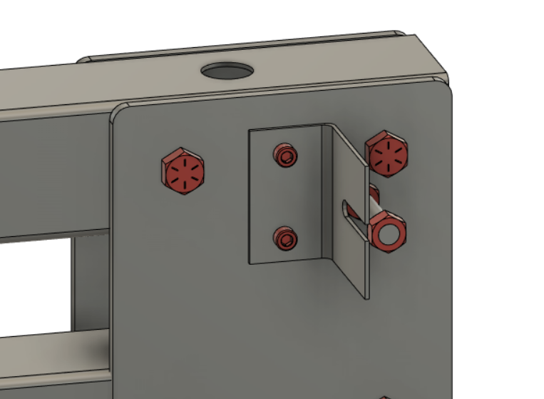

Secure the Idle Belt Mount using 2 of the #10-32 - 5/8” screws to the Y Connecting Plate #2

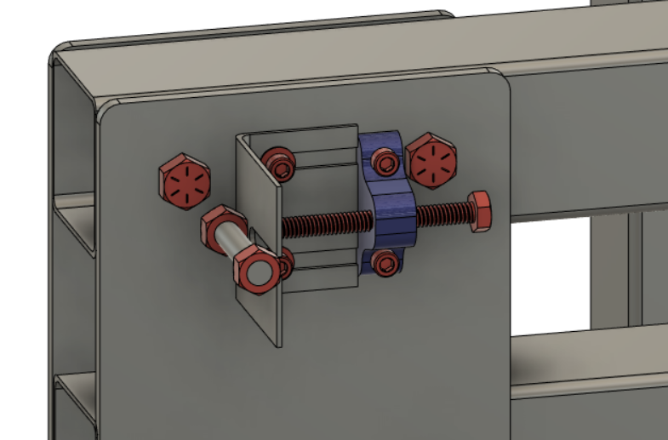

Secure the Active Belt Mount and Belt Tensioner as so to the Y-Connecting Plate #3